

**Submitted To: Submitted By:**

IBM Roshan Gulgulia

UID:15BCS7051

CSE(Hons) Cloud

**DEPARTMENT OF APPLIED SCIENCE & ENGINEERING**

**CHANDIGARH UNIVERSITY**

**GHARUAN, MOHALI, PUNJAB, INDIA-140413**

**2015**

TABLE OF CONTENT

Acknowledgement 3

Brief Discussion of Project: 4

Header Files Used 5

Pre Defined Function 6

User Defined Function 7

Coding 8

Screen Short 20

Conclusion 22

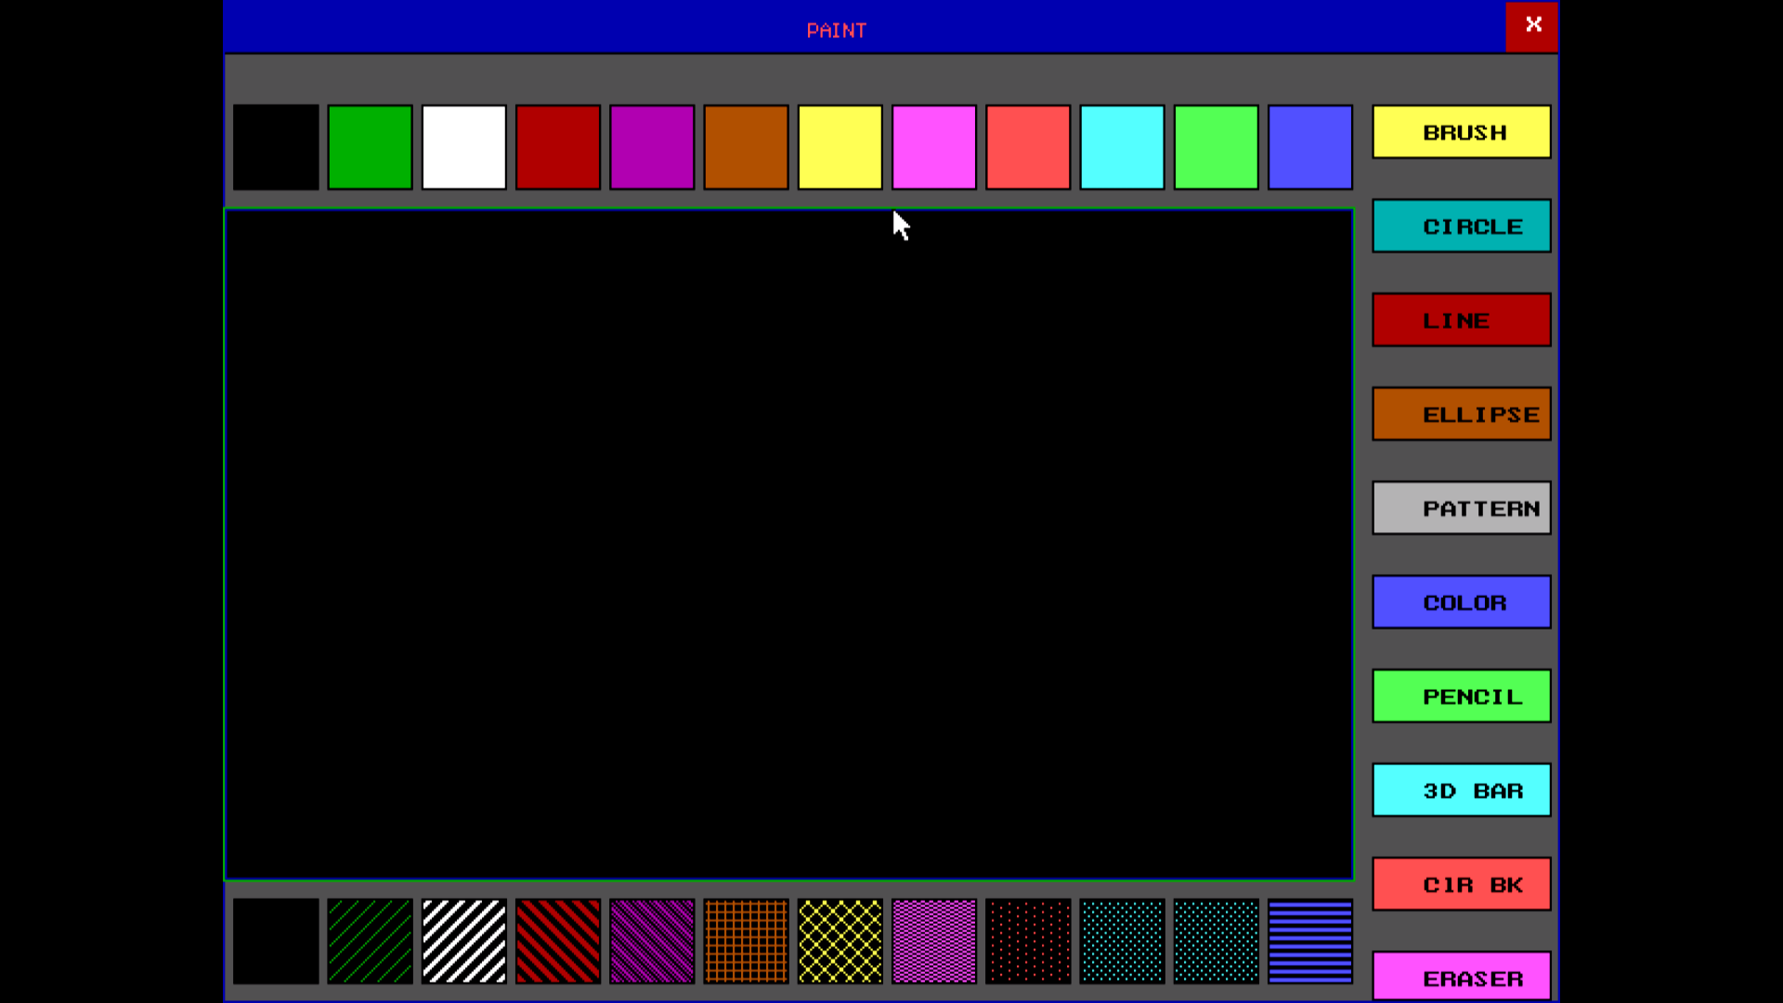

ACKNOWLEDGEMENT

I am using this opportunity to show my project to everyone. who supported me throughout the project. I am thankful for their aspiring guidance, invaluably constructive criticism and friendy advice during the project work. I am sincerely grateful to them for sharing their truthful and illuminating views on a number of issues related to the project.

I Really thankful to NPTEL(online IIT Professors) they teaches me the data structure and algorithm by those concepts i made this program.

I express my warm thanks to our IBM teachers and MY SF Teacher for their support and guidance in my Project

**Brief Discussion of project**

This is my first graphics project. In this project i am using inbilt functions of graphics and in this project i have simply made a layout of paint brush i have use 2 viewports 1st viewport is only for showing the colors and symbols and outlook of page and in second viewport we can draw circle rectangle bar or any line dots and we can also add texture and we can use different colors as per given colors.

Because of less time i cant make my project like autocad actually i want to make my project like autocad but for now this is simply paint brush where we can draw color and we can have fun with this in leisure time.

Moreover this is project is fully graphics based so all codes and coding are done by all graphics function and i also use mouse i.e. my built header file.

In mouse function i have copied the code from internet and made a header file. Rest all will we have when we will use it.

**HEADER FILES**

**graphics.h:** This is my main and important header file in this header file all the functions i.e. circle rectangle bar color and mouse everything is defined in this header file.

**mouse.h:** This is user defined header file which i have made for this project and codes are copied by internet.

**iostream:** This is a header file used in my project for cin i.e input and cout i.e. output and any other functions are also their where the function defination is stored in iostream.

**strings.h**: The string.h header file contanins one variable type,one macro type and several functions for manipulating the char array.

variable type: **size_t.**

Macro type: NULL.

function type: strncpy,strlen,strcat etc.

**windows.h:** The **windows.h** is a [Windows](https://en.wikipedia.org/wiki/Microsoft_Windows)-specific header file which contains declarations for all of the functions in the [Windows API](https://en.wikipedia.org/wiki/Windows_API), all the common macros used by Windows programmers, and all the data types used by the various functions and subsystems. Here i am using for system clear screen.

**dos.h**: this header file i have use to delay the time .

**Pre Defined Functions**

**circle(int,int,int):** to draw a circle with gives cordinates as centre and third arg as radius.

**rectangle(int,int,int,int):**to draw rectangle with first two argument as starting point and ending two are ending point of rectangle

**bar(int,int,int,int):** to draw a bar same as rectangle it just fills color as bar.

**line(int,int,int,int):** to draw a line starting two argument is the starting cordinate and last two argument is the ending cordinate.

**setfillstyle(fill style,color):** to style the bar or any closed curve it takes two argument 1st is for style of filling and 2nd is for color.

**flooffill(int,int,int):** to fill the color to any closed curve of current style.

**exit():** to exit the program.

**setcolor(color):**to set the color it takes an argument of which color to be set as current color.

**ellipse(int,int,int,int,int,int):** to draw an ellipse ist two arguments are the centre of ellipse and third is for starting angle and forth is for ending angle and fifth is for radius of x axis and sixth is for radius of y.

**getch():** to get a character from the user.

**User Defined Function**

**void menu(dictonary *head):** The Main Menu of my Programwhere it will show the different category like to add word to update word or to search or delete etc.

**dictonary* Insert(dictonary *root,char word[],char meaning[]):** this function takes 3 ardument one is head node and other is word and meaning and it also returns the node where the word and meaning is save.

**void search(char name[],dictonary *root):** it takes two argument one searching name and the root address.

**void delty(char name[],dictonary *root):** it takes two argument one deleting name and other is head node.

**void write(dictonary *root):** it takes one argument i.e. head node and this function saves the file in txt format.

**void display(dictonary *root):** it takes one argument i.e. head node and this function display the words with their meaning.

**void gotoxy():** this function is used to move the curser from one place to other.

**void exits():** To Exit The Program.

**void group():** To View The Groupsbelonging to same state and the same age and the same qualification same company etc.

**CODING**

#include<stdio.h>

#include<stdlib.h>

#include<conio.h>

#include<dos.h>

#include<graphics.h>

#include"mouse.h"

void shape()

{

int i,j;

setcolor(8);

setfillstyle(SOLID_FILL,8);//dark Gray;

bar3d(0,0,getmaxx(),getmaxy(),0,0);

setcolor(0);

rectangle(550,50,635,75);

setfillstyle(SOLID_FILL,14);

floodfill(552,70,0);

setcolor(0);

outtextxy(575,60,"BRUSH");

setcolor(0);

rectangle(550,95,635,120);

setfillstyle(SOLID_FILL,3);

floodfill(552,100,0);

setcolor(0);

outtextxy(575,105,"CIRCLE");

setcolor(0);

rectangle(550,140,635,165);

setfillstyle(SOLID_FILL,4);

floodfill(552,145,0);

setcolor(0);

outtextxy(575,150,"LINE");

setcolor(0);

rectangle(550,185,635,210);

setfillstyle(SOLID_FILL,6);

floodfill(552,190,0);

setcolor(0);

outtextxy(575,195,"ELLIPSE");

setcolor(0);

rectangle(550,230,635,255);

setfillstyle(SOLID_FILL,7);

floodfill(552,235,0);

setcolor(0);

outtextxy(575,240,"PATTERN");

setcolor(0);

rectangle(550,275,635,300);

setfillstyle(SOLID_FILL,9);

floodfill(552,280,0);

setcolor(0);

outtextxy(575,285,"COLOR");

setcolor(0);

rectangle(550,320,635,345);

setfillstyle(SOLID_FILL,10);

floodfill(552,325,0);

setcolor(0);

outtextxy(575,330,"PENCIL");

setcolor(0);

rectangle(550,365,635,390);

setfillstyle(SOLID_FILL,11);

floodfill(552,370,0);

setcolor(0);

outtextxy(575,375,"3D BAR");

setcolor(0);

rectangle(550,410,635,435);

setfillstyle(SOLID_FILL,12);

floodfill(552,415,0);

setcolor(0);

outtextxy(575,420,"ClR BK");

setcolor(0);

rectangle(550,455,635,478);

setfillstyle(SOLID_FILL,13);

floodfill(552,460,0);

setcolor(0);

outtextxy(575,465,"ERASER");

}

char chshape(int x1,int y1)

{

if(x1>550&&x1<635 && y1>50&&y1<75)

return 's';

if(x1>550&&x1<630 && y1>95&&y1<120)

return 'c';

if(x1>550&&x1<630 && y1>140&&y1<165)

return 'l';

if(x1>550&&x1<630 && y1>185&&y1<210)

return 'i';

if(x1>550&&x1<630 && y1>230&&y1<255)

return 'p';

if(x1>550&&x1<630 && y1>275&&y1<300)

return 'r';

if(x1>550&&x1<630 && y1>320&&y1<345)

return 'o';

if(x1>550&&x1<630 && y1>365&&y1<390)

return '3';

if(x1>550&&x1<630 && y1>410&&y1<435)

return 'b';

if(x1>550&&x1<630 && y1>455&&y1<478)

return 'e';

else

return 'a';

}

void color()

{

int i,j;

setfillstyle(SOLID_FILL,0);

bar(5,50,45,90);

setfillstyle(SOLID_FILL,2);

bar(50,50,90,90);

setfillstyle(SOLID_FILL,15);

bar(95,50,135,90);

setfillstyle(SOLID_FILL,4);

bar(140,50,180,90);

setfillstyle(SOLID_FILL,5);

bar(185,50,225,90);

setfillstyle(SOLID_FILL,6);

bar(230,50,270,90);

setfillstyle(SOLID_FILL,14);

bar(275,50,315,90);

setfillstyle(SOLID_FILL,13);

bar(320,50,360,90);

setfillstyle(SOLID_FILL,12);

bar(365,50,405,90);

setfillstyle(SOLID_FILL,11);

bar(410,50,450,90);

setfillstyle(SOLID_FILL,10);

bar(455,50,495,90);

setfillstyle(SOLID_FILL,9);

bar(500,50,540,90);

setcolor(0);

for(i=0;i<=500;i+=45)

{

rectangle(i+5,50,i+45,90);

}

}

void text()

{

int i;

setfillstyle(0,7);

bar(5,430,45,470);

setfillstyle(3,2);

bar(50,430,90,470);

setfillstyle(4,15);

bar(95,430,135,470);

setfillstyle(5,4);

bar(140,430,180,470);

setfillstyle(6,5);

bar(185,430,225,470);

setfillstyle(7,6);

bar(230,430,270,470);

setfillstyle(8,14);

bar(275,430,315,470);

setfillstyle(9,13);

bar(320,430,360,470);

setfillstyle(10,12);

bar(365,430,405,470);

setfillstyle(11,11);

bar(410,430,450,470);

setfillstyle(12,10);

bar(455,430,495,470);

setfillstyle(2,9);

bar(500,430,540,470);

setcolor(0);

for(i=0;i<=500;i+=45)

{

rectangle(i+5,430,i+45,470);

}

}

int chcolor(int x1,int y1)

{

if(x1>5&&x1<45 && y1>50&&y1<90)

return 0;

if(x1>50&&x1<90 && y1>50&&y1<90)

return 2;

if(x1>95&&x1<135 && y1>50&&y1<90)

return 15;

if(x1>140&&x1<180 && y1>50&&y1<90)

return 4;

if(x1>185&&x1<225 && y1>50&&y1<90)

return 5;

if(x1>230&&x1<270 && y1>50&&y1<90)

return 6;

if(x1>275&&x1<315 && y1>50&&y1<90)

return 14;

if(x1>320&&x1<360 && y1>50&&y1<90)

return 13;

if(x1>365&&x1<405 && y1>50&&y1<90)

return 12;

if(x1>410&&x1<450 && y1>50&&y1<90)

return 11;

if(x1>455&&x1<495 && y1>50&&y1<90)

return 10;

if(x1>500&&x1<540 && y1>50&&y1<90)

return 9;

else

return 2;

}

int chtext(int x1,int y1)

{

if(x1>5&&x1<45 && y1>430&&y1<470)

return 0;

if(x1>50&&x1<90 && y1>430&&y1<470)

return 3;

if(x1>95&&x1<135 && y1>430&&y1<470)

return 4;

if(x1>140&&x1<180 && y1>430&&y1<470)

return 5;

if(x1>185&&x1<225 && y1>430&&y1<470)

return 6;

if(x1>230&&x1<270 && y1>430&&y1<470)

return 7;

if(x1>275&&x1<315 && y1>430&&y1<470)

return 8;

if(x1>320&&x1<360 && y1>430&&y1<470)

return 9;

if(x1>365&&x1<405 && y1>430&&y1<470)

return 10;

if(x1>410&&x1<450 && y1>430&&y1<470)

return 11;

if(x1>455&&x1<495 && y1>430&&y1<470)

return 12;

if(x1>500&&x1<540 && y1>430&&y1<470)

return 2;

else

return 2;

}

int roshan()

{

int i,k;

clrscr();

gotoxy(50,20);

textcolor(RED+128);

cprintf("Roshan Gulgulia");

for(i=1;i<100;i++)

{

delay(50);

gotoxy(20,10);

textcolor(i+128);

cprintf("Welcome To Roshan's Paint Brush");

}

textcolor(0);

int gdriver = DETECT, gmode, errorcode;

initgraph(&gdriver, &gmode, "C:\\TC\\bgi");

errorcode = graphresult();

if (errorcode != grOk) /* an error occurred */

{

printf("Graphics error: %s\n", grapherrormsg(errorcode));

printf("Press any key to halt:");

getch();

exit(1); /* return with error code */

}

int j;

char ch,f;

shape();

setfillstyle(SOLID_FILL,1);

bar(0,0,getmaxx()-25,25);

setfillstyle(SOLID_FILL,4);

bar(getmaxx()-25,0,getmaxx(),25);

setcolor(0);

line(0,25,getmaxx(),25);

setcolor(BLUE);

rectangle(0,0,getmaxx(),getmaxy());

setfillstyle(1,0);

bar3d(1,100,540,420,0,0);

setcolor(GREEN);

rectangle(0,99,541,421);

color();

text();

setcolor(WHITE);

textcolor(4+BLINK);

outtextxy(getmaxx()-15,8,"X");

setcolor(12);

settextstyle(2,0,0);

outtextxy(280,8,"PAINT");

setcolor(0);

setviewport(1,100,540,420,1);

char fc;

//unisigned int size;

int t,w,x1,y1,x,y,button;

void *pic;

while(1)

{

if(kbhit())

{

fc=getch();

if(fc==27)

exit(1);

}

showmouseptr();

setfillstyle(EMPTY_FILL,0);

//mouserestrict(0,0,getmaxx(),getmaxy());

cordinate(&x1,&y1,&button);

if(x1>549&&x1<636 && y1>10&&y1<480 && button==0)

ch=chshape(x1,y1);

if(x1>4&&x1<541 && y1>429&&y1<471 && button==0)

{

t=chtext(x1,y1);

setfillstyle(t,w);

bar(1,100-96,540,420);

}

if(x1>4&&x1<541 && y1>49&&y1<91 && button==0)

{

w=chcolor(x1,y1);

setcolor(chcolor(x1,y1));

}

if(ch=='3')

{

while(1)

{

button=0;

cordinate(&x1,&y1,&button);

if(button==1)

{

x=x1;y=y1;

break;

}

}

int a=1;

while(a==1)

{

a=ButtClicked();

cordinate(&x1,&y1,&button);

}

moverel(20,20);

setcolor(w);

bar3d(x,y-95,x1,y1-96,0,0);

}

if(ch=='l')

{

while(1)

{

button=0;

cordinate(&x1,&y1,&button);

if(button==1)

{

x=x1;y=y1;

break;

}

}

int a=1;

while(a==1)

{

a=ButtClicked();

cordinate(&x1,&y1,&button);

}

setcolor(w);

line(x,y-95,x1,y1-95);

}

if(ch=='s')

{

while(1)

{

button=0;

cordinate(&x1,&y1,&button);

if(button==1)

{

x=x1;y=y1;

break;

}

}

int a=1;

while(a==1)

{

a=ButtClicked();

cordinate(&x1,&y1,&button);

setcolor(w);

//setfillstyle(SOLID_FILL,w);

for(i=0;i<10;i++)

circle(x1,y1-95,i);

//floodfill(x1,y1-95,w);

}

}

if(ch=='c')

{

while(1)

{

button=0;

cordinate(&x1,&y1,&button);

if(button==1)

{

x=x1;y=y1;

break;

}

}

int a=1;

while(a==1)

{

a=ButtClicked();

cordinate(&x1,&y1,&button);

}

setcolor(w);

circle(x,y-95,x1-x);

}

if(ch=='o')

{

while(1)

{

button=0;

cordinate(&x1,&y1,&button);

if(button==1)

{

x=x1;y=y1;

break;

}

}

int a=1;

while(a==1)

{

a=ButtClicked();

setcolor(w);

cordinate(&x1,&y1,&button);

putpixel(x1,y1-95,w);

}

}

if(ch=='e')

{

while(1)

{

button=0;

cordinate(&x1,&y1,&button);

if(button==1)

{

x=x1;y=y1;

break;

}

}

int a=1;

while(a==1)

{

a=ButtClicked();

cordinate(&x1,&y1,&button);

}

setcolor(0);

bar3d(x,y-95,x1,y1-95,0,0);

}

if(ch=='r')

{

while(1)

{

button=0;

cordinate(&x1,&y1,&button);

if(button==1)

{

x=x1;y=y1;

break;

}

}

setfillstyle(SOLID_FILL,w);

floodfill(x1,y1-95,w);

}

if(ch=='b')

{

while(1)

{

button=0;

cordinate(&x1,&y1,&button);

if(button==1)

{

x=x1;y=y1;

break;

}

}

setfillstyle(SOLID_FILL,w);

floodfill(x1,y1,w);

}

if(ch=='p')

{

while(1)

{

button=0;

cordinate(&x1,&y1,&button);

if(button==1)

{

x=x1;y=y1;

break;

}

}

setfillstyle(5,w);

floodfill(x1,y1,w);

}

if(ch=='i')

{

while(1)

{

button=0;

cordinate(&x1,&y1,&button);

if(button==1)

{

x=x1;y=y1;

break;

}

}

int a=1;

while(a==1)

{

a=ButtClicked();

cordinate(&x1,&y1,&button);

}

setcolor(w);

ellipse(x,y-95,0,360,x1-x,y1-95-y-95);

}

}

}

void main()

{

roshan();

getch();

}

**OUTPUT**

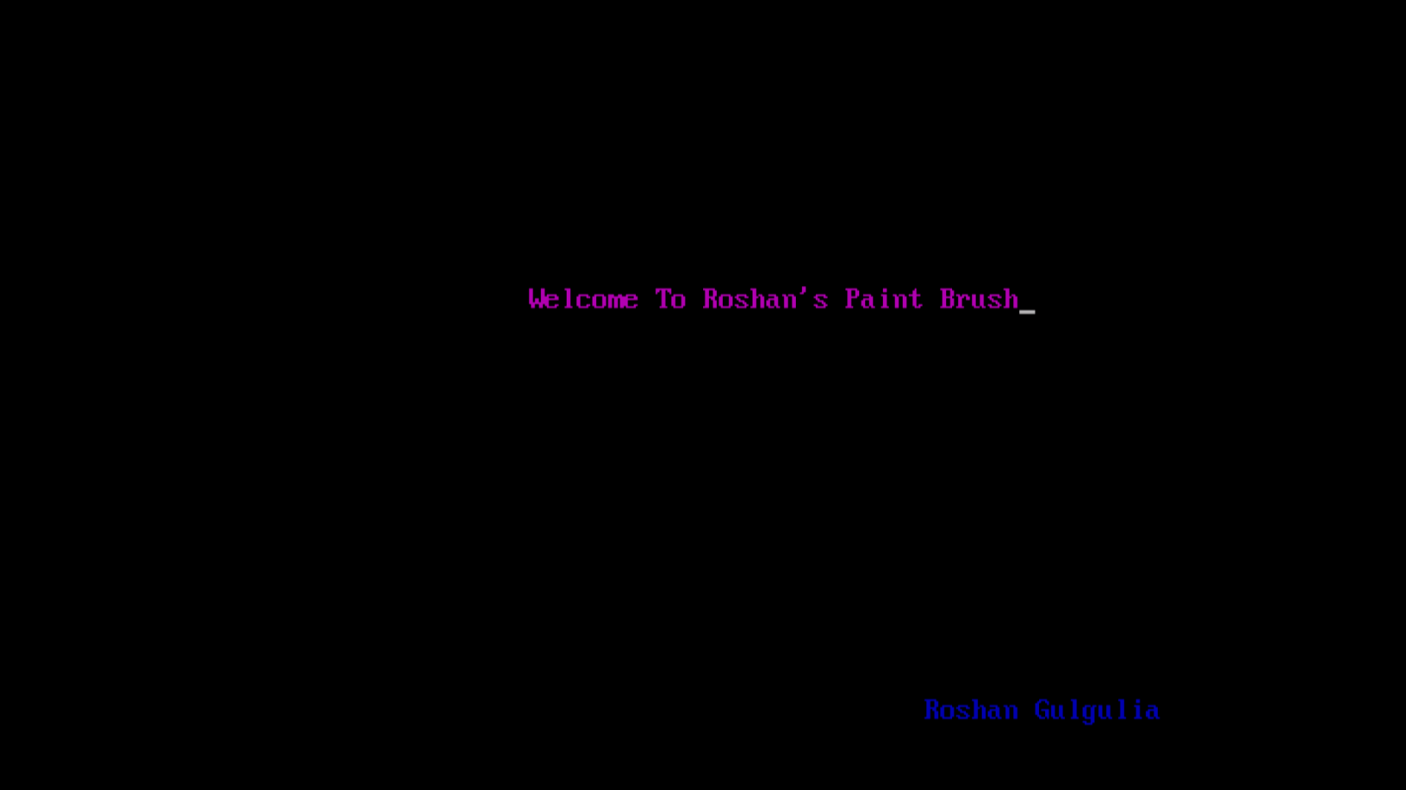

Fig:1.1

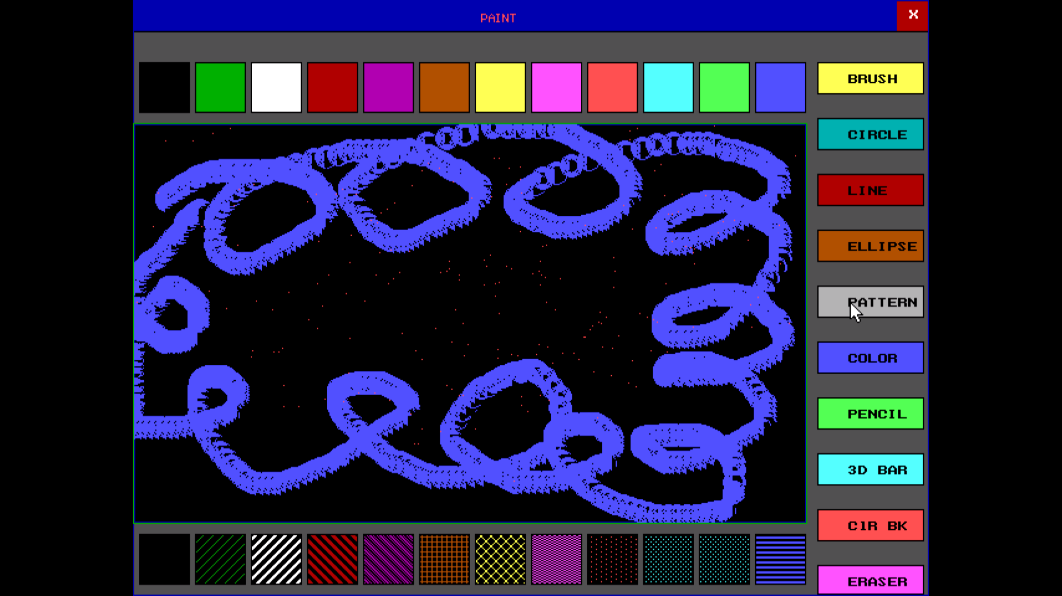

Fig:1.2

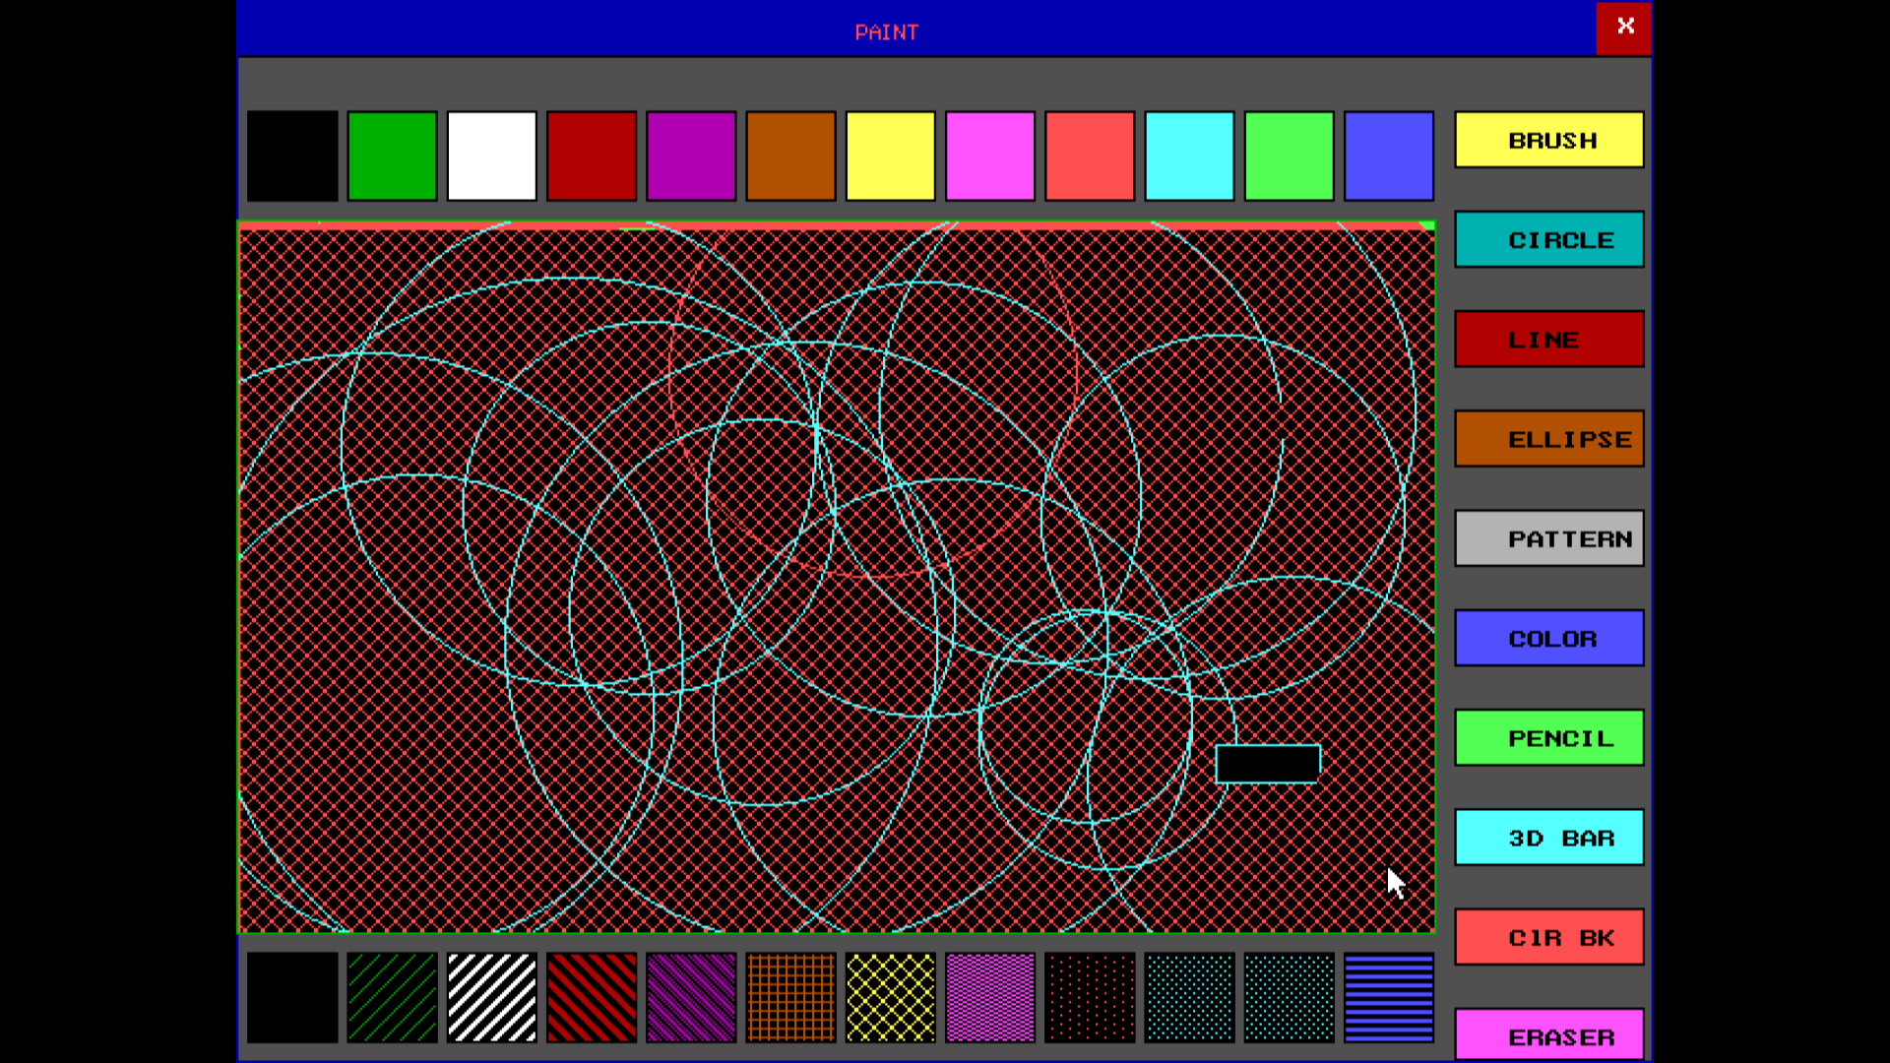

Fig:1.3

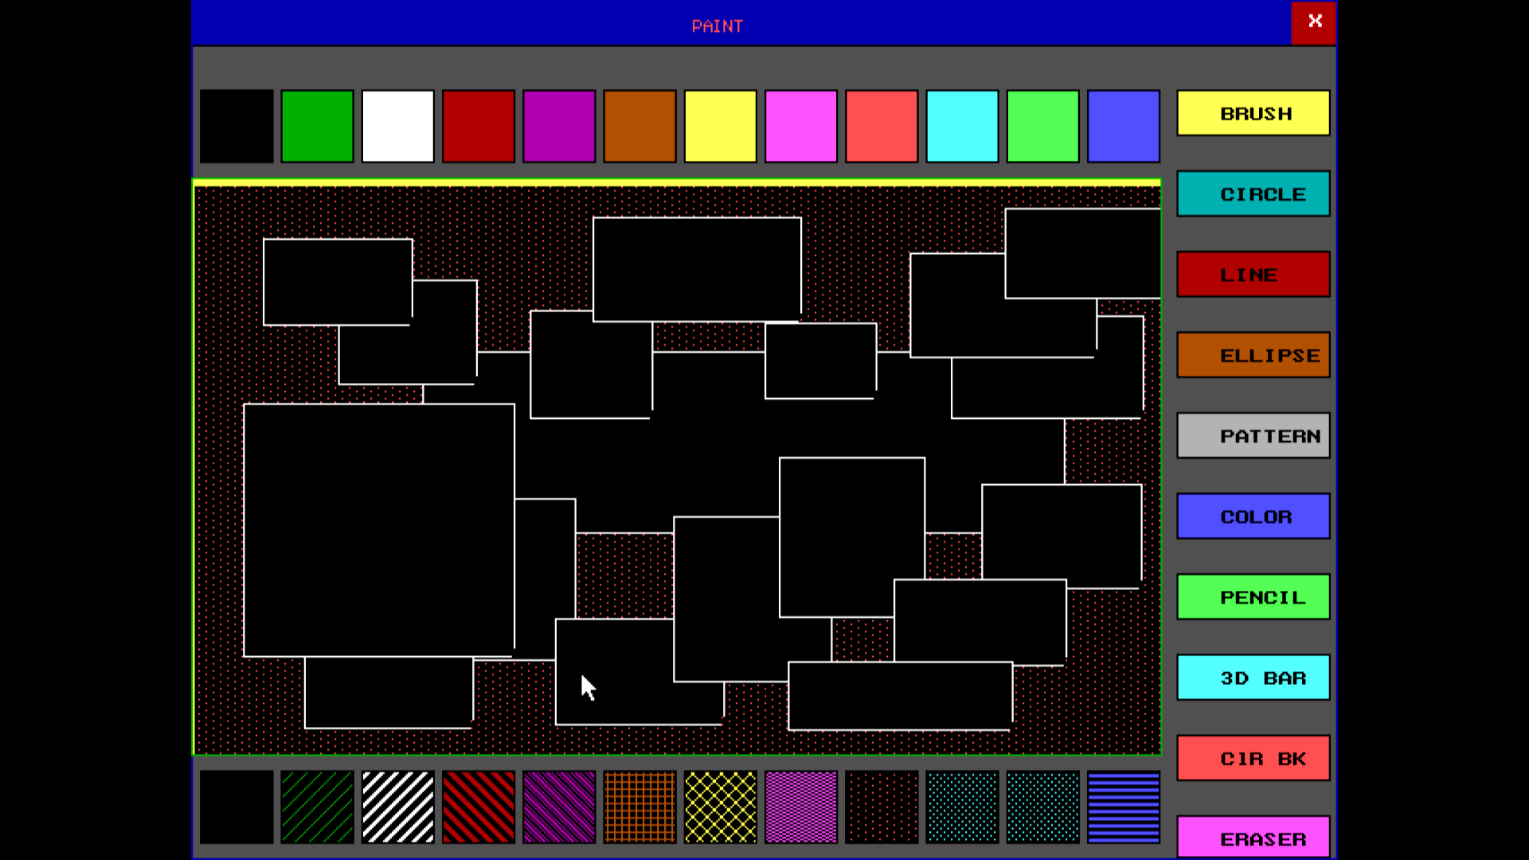

Fig:1.4

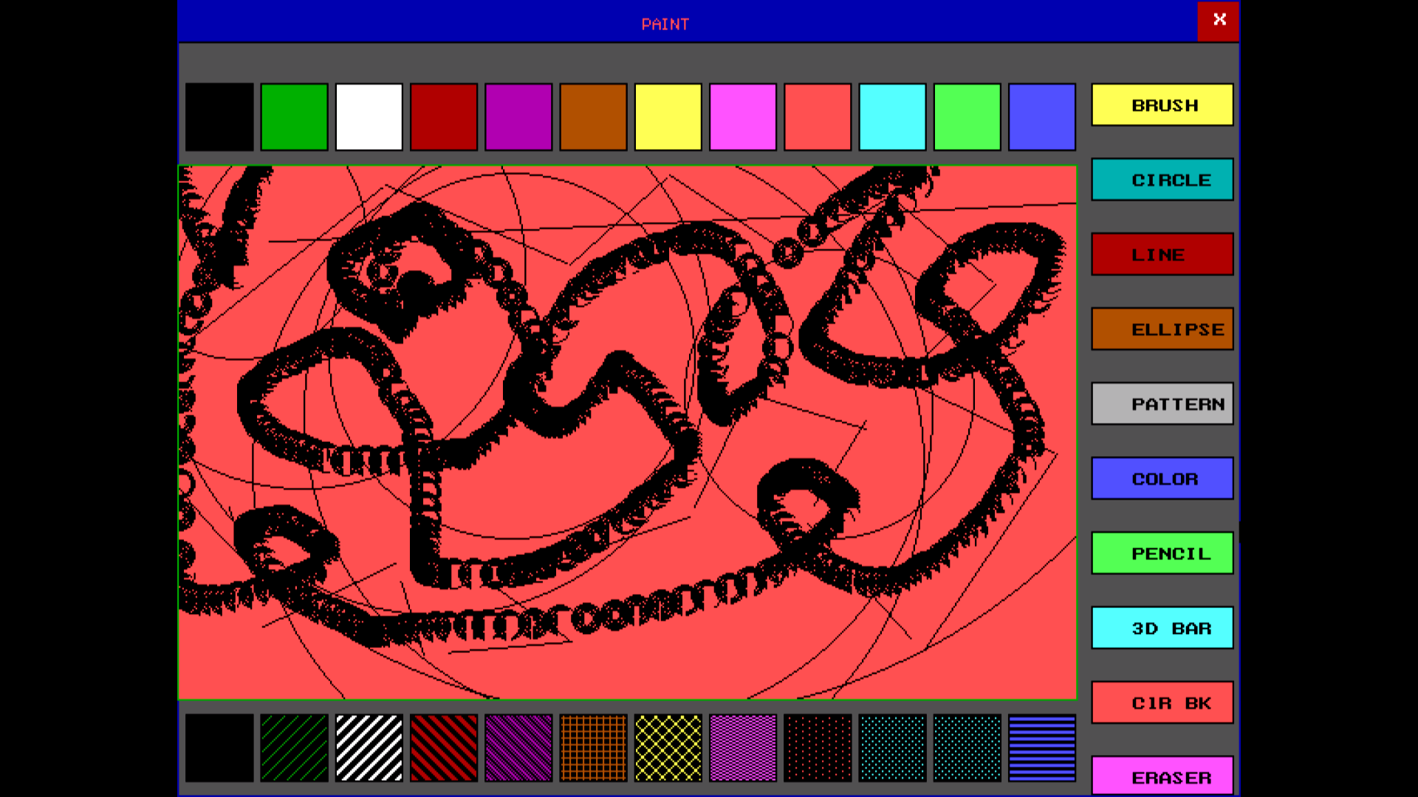

Fig:1.5

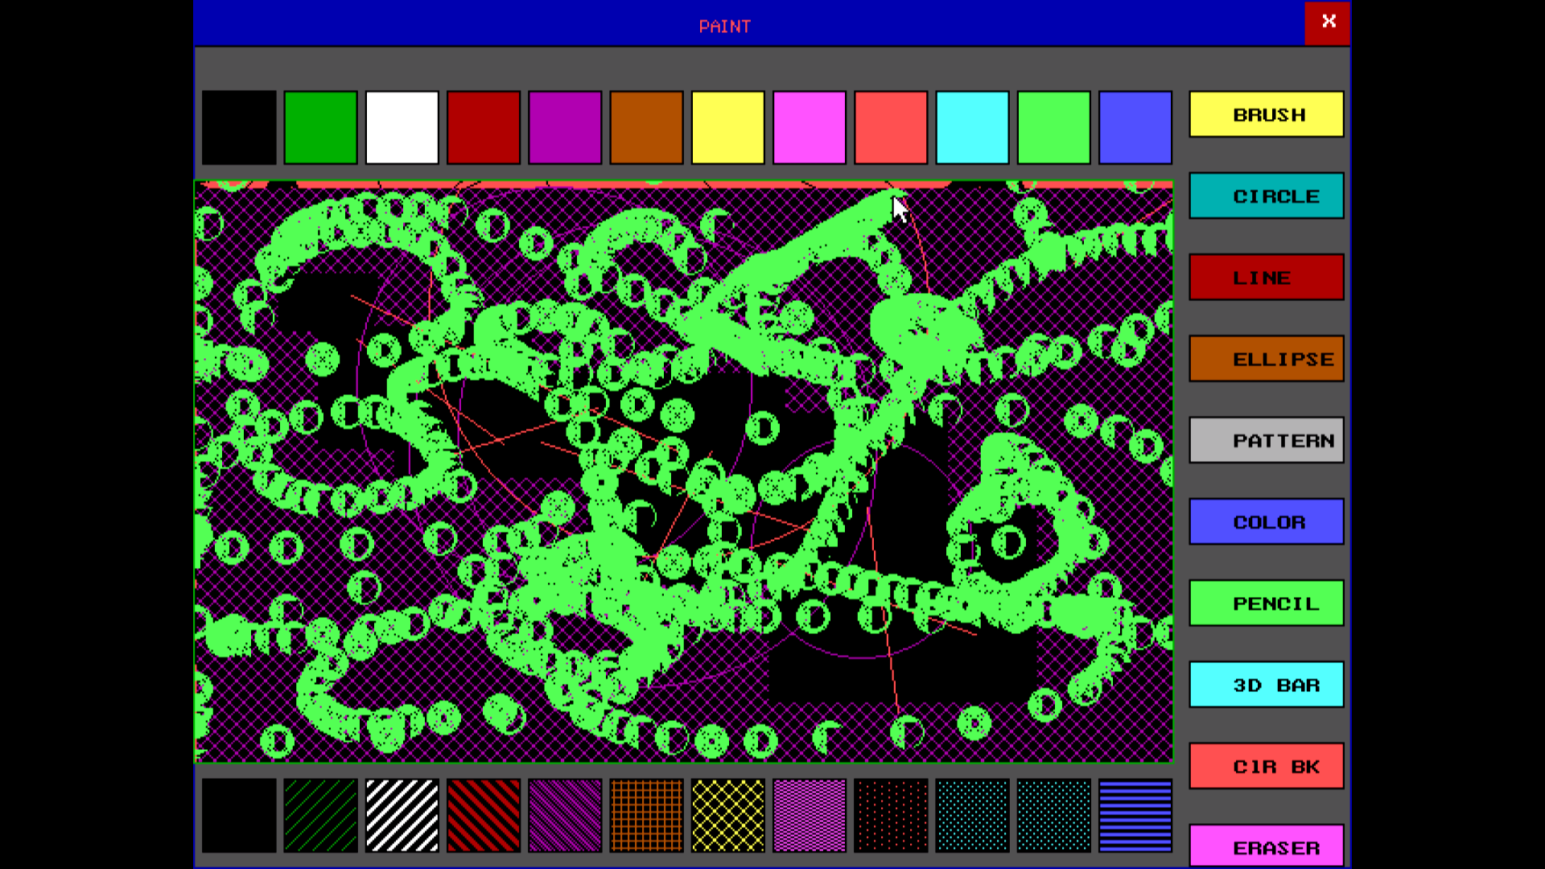

Fig:1.6

CONCLUSION

We are very much thankful to our teachers for all the support they has given to us. We learn many new functions while doing this project. This is only their support that we are able to Complete the project with in time. We are very grateful for their cooperation in completion of this project. He acted as the guiding spirit behind the completion of this project.

Special Thanks to our IBM Experts that they given us their time to clear our doubts and give us an exert lecture. They also helped in completion of Project.